SQL LAB 3

Task 1: Update the Student table with the following information:

Change the email to 'jane_Smith@example.com' Where FirstName is 'Jane' and LastName is 'Smith';

SET SQL_SAFE_UPDATES = 0;

UPDATE Student

SET Email = 'jane_Smith@example.com'

WHERE FirstName = 'Jane' AND LastName = 'Smith';

SET SQL_SAFE_UPDATES = 1;

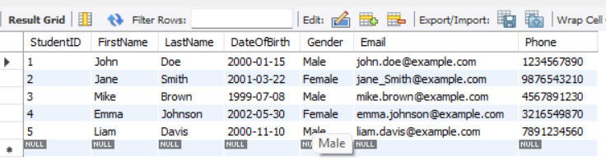

 Update the Instructor with the following information: Change the email to 'rogerwhite@example.com' Where FirstName of the instructor is 'Roger' and LastName is 'White';

SET SQL_SAFE_UPDATES = 0;

UPDATE Instructor

SET email = 'rogerwhite@example.com'

WHERE FirstName = 'Roger' AND LastName = 'White';

SET SQL_SAFE_UPDATES = 1;

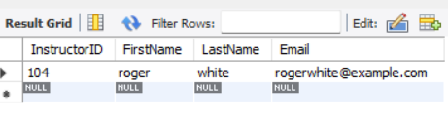

 Task 2: Delete record from the Student table on following condition:

Delete student/students records from the Student table where last name is Smith.

DELETE FROM Student

WHERE LastName = 'Smith';

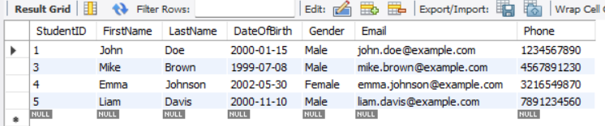

Task 3: List the student whose first name starts with J. Submission:

SELECT * FROM Student

WHERE FirstName LIKE 'J%';

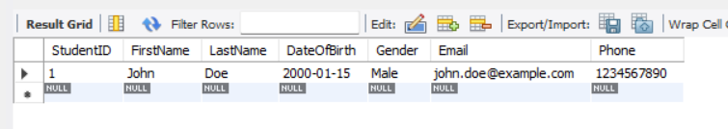

Lab 2.Database Schema: Consider a simple database with one tables: Employee

Employee Table:

* emp_id (Primary Key)
* first_name
* last_name
* age
* email

Query : CREATE TABLE Employee (emp_id INT PRIMARY KEY,

first_name VARCHAR(50),

last_name VARCHAR(50),

age INT,

email VARCHAR(100) UNIQUE

);

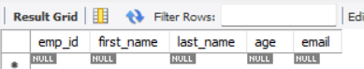

Task 1: Insert Data Write an SQL INSERT statement to insert data into the Employee table.

INSERT INTO Employee (emp_id, first_name, last_name, age, email)

VALUES

(1, 'John', 'Doe', 28, 'john.doe@example.com'),

(2, 'Jane', 'Smith', 35, 'jane.smith@example.com'),

(3, 'Alice', 'Johnson', 22, 'alice.johnson@example.com'),

(4, 'Bob', 'Brown', 40, 'bob.brown@example.com');

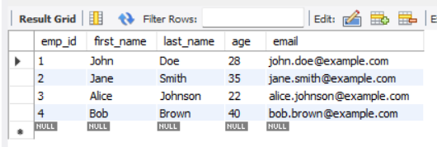

Task 2: Retrieving Data Write an SQL SELECT statement to retrieve the first_name and last_name of all employees from the Employee table.

SELECT first_name, last_name FROM Employee;

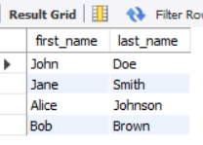

 Task 3: Filtering Data Write an SQL SELECT statement to retrieve the first_name, last_name, and age of employees who are older than 30 years.

SELECT first_name, last_name, age

FROM employee

WHERE age > 30;

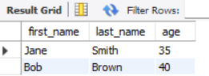

 Task 4: Updating Data Write an SQL UPDATE statement to increase the age of employees by 1 year for all employees older than 25

SET SQL_SAFE_UPDATES = 0;

UPDATE employee SET age = age + 1 WHERE age > 25;

SET SQL_SAFE_UPDATES = 1;

